**Soarian to MedAptus**

**ADT Interface Requirements**

**Version 1.2**

**Prepared By: Lois Whitley, Art Schwartz, Thomas Fredrickson**

**Date: 12/10/2018**

Document Control 3

Resources 3

Project Distribution List 3

Document Version Control 3

1. Introduction 4

1.1 Purpose 4

1.2 Project Scope 4

1.3 Terminology Standards 4

1.3.1 Acronyms 4

1.3.2 Glossary 4

1.4 Document References 4

*2.* Diagram 5

3. Requirements 6

3.1 Functional Requirements 6

3.2 Non-Functional Requirements –N/A 6

3.3 Messaging Protocols 7

3.3.1 Inbound to the BayCare Cloverleaf 7

3.3.2 Outbound to the BayCare Cloverleaf 7

3.3.3 Inbound to the Vendor 7

3.3.4 Outbound to the Vendor 7

4. HL7 Messaging 7

4.1 Messaging Format 7

4.1.1 Segments 7

4.1.2 Messaging Event Types 8

4.1*.*3 Cloverleaf Configuration Files 8

4.1.4 Cloverleaf Site Location 8

4.2 Data Transformation Requirements 9

4.3 Sample Message 12

5. Testing 13

5.1. Unit Testing Scenarios 13

5.2 Integrated Testing Scenarios -N/A 14

5.3 Testing Approvals 14

Appendix A: Risks and Concerns –N/A 15

Appendix B: Issues List –N/A 15

# **Document Control**

## Resources

|  |  |  |
| --- | --- | --- |
| **Name** | **Role** | **Email** |
| Art Schwartz | Cloverleaf Developer | [Art.Schwartz@baycare.org](mailto:Art.Schwartz@baycare.org) |
| Thomas Fredrickson | Cloverleaf Developer | [Thomas.Fredrickson@baycare.org](mailto:Thomas.Fredrickson@baycare.org) |
| Sarah Thies | Cerner FSI Developer | [Sarah.Thies@baycare.org](mailto:Sarah.Thies@baycare.org) |
| Reginah Musyoki-Howell | IS Project Manager, Sr. | [Reginah.Musyoki-Howell@baycare.org](mailto:Reginah.Musyoki-Howell@baycare.org) |
| Michael Marsan | MedAptus Technical Contact | [mmarsan@medaptus.com](mailto:mmarsan@medaptus.com) |
| Esquivel, Kimberley | Manager, IS Physician Systems-EPM | [Kimberley.Esquivel@baycare.org](mailto:Kimberley.Esquivel@baycare.org) |
| Abrahamson, Karla | Manager, EMR Technical Liaison | [Karla.Abrahamson@baycare.org](mailto:Karla.Abrahamson@baycare.org) |
| Lindstrom, Doug | Manager, IS Soarian Applications | [Douglas.Lindstrom@baycare.org](mailto:Douglas.Lindstrom@baycare.org) |

## Project Distribution List

## Document Version Control

|  |  |  |  |
| --- | --- | --- | --- |
| **Version** | **Date** | **Modifier** | **Description** |
| V1.0 | 10/15/2015 | Lois Whitley | Originally Created |
| V1.1 | 4/11/2016 | Art Schwartz | Removed statement about physician filtering |
| V1.2 | 12/7/2018 | Tiffany Bohall | Compared to current configuration build and updated where necessary |
|  |  |  |  |

# 1. Introduction

## 1.1 Purpose

This document describes the interfaces required between MedAptus ASP and Soarian, Cerner PowerChart Ambulatory and GE Centricity Business. This software enables employed BayCare Physicians to capture professional charges in GE Centricity Business.

## 1.2 Project Scope

This software requires several Interfaces:

1. Inbound ADT from Soarian that provides real time HL7 visit and demographic data
2. Outbound professional charge data from MedAptus to GE Centricity Business in the form of an HL7 DFT nightly export
3. Inbound EMR inpatient rounding list interface (care team list) from Cerner EMR (may be a CCL ops job)

## 1.3 Terminology Standards

### 1.3.1 Acronyms

ADT – Admission, Discharge, Transfer Message

ASP – Application Service Provider; accessed by users through a web browser

DFT – Detail Financial Transaction Message

GECB – GE Centricity Business

PCA – Cerner PowerChart Ambulatory

### 1.3.2 Glossary

List the terms that require definition with respect to Cloverleaf and the product whose requirements are defined in this document. The definitions are specific to this document and may not be identical to the definitions of these terms in common use.

## 1.4 Document References

1. MedAptus Charge Outbound Standard – 2015-01

2. MedAptus Data Flow

3. MedAptus High Level ADT – 2014-01

4. MedAptus Scenarios for EMR Integration – 2014-01

# *2.* Diagram

Provide a solution diagram that depicts the integration of components specified in this IDBB. This diagram must include the data flow for the interfaces (source and target).

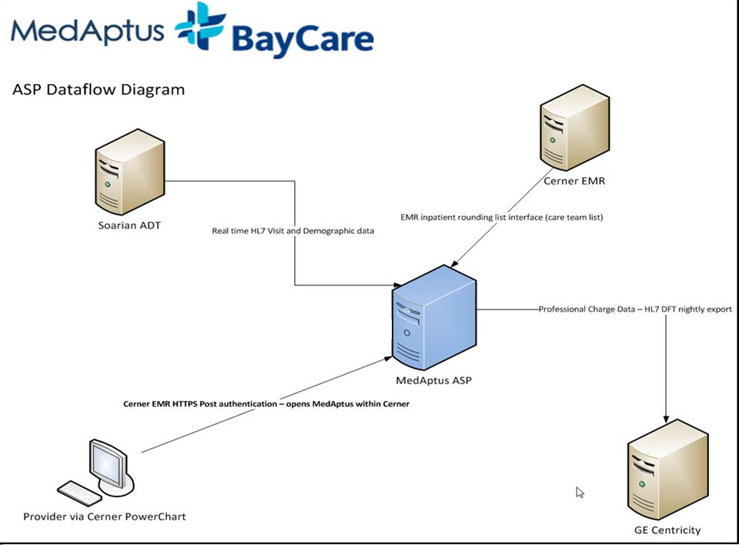

# 3. Requirements

## 3.1 Functional Requirements

Provide detail for the below functional requirements. The message transformation requirements for the components defined in this specification should be specified in section 4.2 of this document.

|  |  |  |
| --- | --- | --- |
| **Cloverleaf** |  |  |
| **Number** | **Requirement Name** | **Requirement Description** |
| FR.2015.1.0 | tpsAdvHL7Filter on the route | Patient Status: PV2.24 =Scheduled, suppress the transaction  Behavioral Health locations: MSH.3 = BLM, WBH, SIP, ISU, CRC, BHO, suppress the transactions  Hospital Service: PV1.10= INF, IVR, MRI, ULT, PNS, IVA, PET or NPY suppress the transaction.  Class allowance: PV1.2 =E, I or O continue transaction |
| FR.2018.12.7 | Hospital Service IF statement in the translation file | Outpatient hospital service filtering: If PV1.2 = O and if PV1.10 =  ASC, BAR, CAR, CCC, CCL, CDH, ECH, EEG, EKG, END, ENT, ETT, EPS, HRV, MAT, MED, MFM, NBF, NEU, NIL, NST, NSY, NUC, OBS, OSV, PAT, PED, PIAm PIP, PMC, PSV, PSY, PYD, RAD, RHB, RST, SDS, SLP, SUR, THO, WHC, XRT |

## 3.2 Non-Functional Requirements –N/A

Provide concise detail for the below non-functional requirements. The below requirements must be evaluated for every project.

|  |  |  |
| --- | --- | --- |
| **Cloverleaf** |  |  |
| **Number** | **Requirement Name** | **Requirement Description** |
|  |  | Click here to enter text. |

## 3.3 Messaging Protocols

Below are listed the details for the messaging protocols that will be leveraged for this integration. Please see the reference document located on the Integration SharePoint server: <insert link to document here>

### 3.3.1 Inbound to the BayCare Cloverleaf

* TCP/IP

### 3.3.2 Outbound to the BayCare Cloverleaf

* N/A

### 3.3.3 Inbound to the Vendor

* N/A

### 3.3.4 Outbound to the Vendor

* TCP/IP

# 4. HL7 Messaging

## 4.1 Messaging Format

### 4.1.1 Segments

The segments utilized for this interface are:

MSH

EVN

PID

PV1

[{ROL}]

[{

IN1

[IN2]

}]

*Message Construction Notes:*

*[Square Brackets] – Optional*

*{Curly Brackets} – Repeatable*

*MSH – Message Header*

*EVN – Event segment*

*PID – Patient ID segment*

*PV1 – Patient Visit segment*

*IN1 – Insurance segment*

*IN2- Additional Insurance Info segment*

*[{ – Start of optional, repeatable group*

*}] – End of optional, repeatable group*

### 4.1.2 Messaging Event Types

Below are the messages types necessary for this integration

|  |  |
| --- | --- |
| **Event Type** | **Description** |
| A01 | Admit a patient |
| A02 | Transfer a patient |
| A03 | Discharge a patient |
| A04 | Register a patient |
| A06 | Transfer an Outpatient to Inpatient |
| A07 | Transfer and Inpatient to Outpatient |
| A08 | Update patient info |
| A11 | Cancel Admit |
| A13 | Cancel Discharge |
|  |  |

### 4.1*.*3 Cloverleaf Configuration Files

Xlate = soarf_medaptus_adt

Variant=Inbound Soarian (2.6) ADT_A01 outbound Cerner 2.6 ADT_A01

### 4.1.4 Cloverleaf Site Location

Soarf_adt_ent

## 4.2 Data Transformation Requirements

| **Field Description** | **HL7 Field Loc.** | **Required Y/N** | **Notes** |
| --- | --- | --- | --- |
| Hospital Service Suppression | PV1.10 | Y | If PV1.2 = O, send PV1.10 value to a variable ‘@goodHospitalService’ with TCL proc that sets the following services to a validation list: {ASC BAR CAR CCC CCL CDH ECH EEG EKG END ENT ETT EPS HRV MAT MED MFM NBF NEU NIL NST NSY NUC OBS OSV PAT PED PIA PIP PMC PSV PSY PYD RAD RHB RST SDS SLP SUR THO WHC XRT}, if output of variable does not qualify on values listed, suppress transaction because hospital service is not ‘good!’ |
| Message Header Segment | Varies |  | Pathcopy entire MSH segment |
| Receiving Application | MSH.5 | Y | Hard coding “MEDAPTUS” |
| Receiving Facility | MSH.6 | Y | Hard coding “MEDAPTUS” |
| Version ID | MSH.12 | Y | Hard coding “2.3” |
| Event Type Code | EVN.1 | Y | Copy |
| Date/Time Planned Event | EVN.2 | N | Copy |
| Operator ID | EVN.5 | N | Copy |
| Set ID | PID.1 | Y | Copy |
| Patient ID Number (CPI) | PID.2.0 | Y | Copy |
| Patient ID Assigning Authority | PID.2.4 | N | Hard coding “CPI” |
| Patient ID Number (MRN) | PID.3.0 | Y | Copy |
| Patient ID Assigning Authority | PID.3.4 | N | Hard coding “MRN” |
| Patient Name | PID.5.0  PID.5.1  PID.5.2  PID.5.3 | Y | Copy |
| Patient date of birth | PID.7 | Y | Copy |
| Patient sex | PID.8 | Y | Copy |
| Patient Address | PID.11.0  PID.11.1  PID.11.2  PID.11.3  PID.11.4 | N | Copy |
| Patient Phone Number: Home and Business | PID.13  PID.14 | Y | Iterate through all repeating instances of PID.13 to copy phones numbers;  If PID.13.1 does not =”NET”, send any repeating instance of subfield .6 to a variable with TCL proc that isolates each phone number component and then concatenate entire phone number into subfield 0. If PID.13.1=“WPN”, perform same copy action with TCL variable isolation and then concatenate output into PID.14.0. |
| Marital Status | PID.16 | N | Copy |
| Patient Account Number | PID.18 | Y | Copy |
| Social Security Number | PID.19 | Y | Copy outbound with TCL proc that populates SSN to 9 digits with leading 0’s where appropriate. |
| Patient Additional Demographics | PD1.4 | N | Interate through repeating ROL segments and IF ROL.3 =”PP” and ROL.2 does not =”DE”, pathcopy ROL.4 to PD1.4 |
| Patient Visit segment | Varies | Y | Pathcopy entire Patient Visit Segment |
| Admit Reason | PV2.3 | Y | Copy |
| Role: Role Instance ID, Action Code, Role-ROL, Role Person, Role begin date/time, Provider Type and Provider Phone | ROL.1  ROL.2  ROL.3  ROL.4  ROL.5  ROL.9  ROL.12 | Y | Interate through repeating ROL segments and IF ROL.3 =”CP” (for Consulting Providers), copy ROL.1, ROL.2, ROL.3, ROL.4, ROL.5, ROL.9 and ROL.12 outbound. |
| Insurance Segment 1: Set ID, Insurance plan ID, Insurance Company ID, Insurance Company Name, Insurance Company Address, Insurance Company Phone Number, Group Number, Plan Effective Date, Plan Expiration Date, Authorization Information, Name of Insured: Family, Given, Second and Further, Suffix, Insured’s Relationship to Patient, Insured’s Date of Birth, Insured’s Address: Street Address, Other Designation, City, State, Zip or Postal Code, Coordination of Benefit Priority, Policy Deductible, Insured’s Administrative Sex | Varies | Y | Iterate through IN1 repeating segment group and If IN1.2 does not =null, copy IN1.1, IN1.2, IN1.3, IN1.4, IN1.5, (iterate through IN1.7 and if IN1.7.1 =’WPN’, concatenate IN1.7.5 with IN1.7.6 with TCL proc that adds phone number formatting (parenthesis, dash) and copy outbound) IN1.7.0, IN1.8, IN1.12, IN1.13, IN1.14, IN1.16.0, IN1.16.1, IN1.16.2, IN1.16.3, IN1.17, IN1.18, IN1.19.0, IN1.19.1, IN1.19.2, IN1.19.3, IN1.19.4, IN1.22, IN1.36, IN1.43. |
| Insurance Plan ID | IN2.2 | N | Copy |
| Insurance Company ID | IN2.3 | N | Copy |

## 4.3 Sample Message

*** Please note, these HL7 transactions were pulled from the test ADT feed! ***

MSH|^~\&|SOARF|BRM|MEDAPTUS|MEDAPTUS|201812071033||ADT^A04|b5cb9c3b-7b3f-4a1e-8e32-cf23a65974e5|P|2.3

EVN|A04|201812071033|||amy48634

PID|1|810070189^^^^CPI|7000059010^^^^MRN||BURTMAN^SIMONE||19641119|M|||123 MAIN ST^^Dunedin^FL^34698||727-999-9999^PRN|||M||6000091179

PD1||||062321^Stephenson^Luke^Roy^^PRN^1427258607^NPI

PV1|1|E||Emergency|||062321^Stephenson^Luke^Roy^^PRN^1427258607^NPI|||ERD|||N|EO|||062321^Stephenson^Luke^Roy^^PRN^1427258607^NPI|E|5400003614^^^504^VN^^20181207|HMO|||||||||||||||||||20874|||||201812071009|||||||V

PV2|||^CHOLELITHIASIS

IN1|1|136|410|Aetna|PO BOX 14079||(800)432-2574|||||||||BURTMAN^SIMONE|6|19641119|123 MAIN ST^^Dunedin^FL^34698|||1||||||||||||||W264084431|||||||M

MSH|^~\&|SOARF|SAH|MEDAPTUS|MEDAPTUS|201812071334||ADT^A01|e310ba65-acf9-4d82-96ff-fd080e79f86a|P|2.3

EVN|A01|201812071334|||amy48634

PID|1|810070190^^^^CPI|7000059011^^^^MRN||RATH^YVES M||19710831|M|||123 MAIN ST^^Dunedin^FL^34698||727-999-9999^PRN|||M||6000091192

PD1||||062321^Stephenson^Luke^Roy^^PRN^1427258607^NPI^16795^PRDOC^SAH

PV1|1|I|3NW^3NWX^02^SAH|Emergency|||062321^Stephenson^Luke^Roy^^PRN^1427258607^NPI^16795^PRDOC^SAH|||MED|||N|RP|||062321^Stephenson^Luke^Roy^^PRN^1427258607^NPI^16795^PRDOC^SAH|I|5400003630^^^504^VN^^20181207|PPO|||||||||||||||||||9046|||||201812071327|||||||V

PV2|||^CHEST PAIN

IN1|1|135|410|Aetna|PO BOX 14079||(800)344-3496|||||||||RATH^YVES M|6|19710831|123 MAIN ST^^Dunedin^FL^34698|||1||||||||||||||W260694709|||||||M

# **5. Testing**

## 5.1. Unit Testing Scenarios

|  |  |
| --- | --- |
| **Scenario** | **Expected Result** |
| Admit several patients– IP, OSV, etc. | Verify the admission display in MedAptus in a status of Admitted, confirm pt demographics |
| Change several inpatient admitted statuses from Admitted to Cancelled | Verify the admission display in MedAptus in a status of Cancelled |
| From prior example, undo the cancellations | Verify the admission display in MedAptus in a status of Admitted |
| Change a group of inpatient admission statuses (at least one patient per provider) from Admitted and Transfer to a different location | Verify the admission display in MedAptus in a status of Transferred and has been transferred to new location |
| Discharge several inpatients | Verify discharges in MedAptus |
| Register several OSVervation patients, then convert to inpatient and transfer to an inpatient floor. | Confirm flow of OSVervation patient to correct location in MedAptus, then confirm status change and transfer success. |
| From prior example, cancel the transfer | Verify the admission display in MedAptus in a status of admitted and pt has been set back to correct location |
| Update Patient Demographics | Verify update in MedAptus |
| Enter a reason for visit | Verify reason for visit appears in MedAptus |
| Enter admissions for several different hospitalists with IN pt type | Admissions appear in MedAptus with correct provider/group/location and Pt demographics are correct |
| Enter admissions for several different hospitalists with ER pt type | Admissions appear in MedAptus with correct provider/group/location and Pt demographics are correct |
| Enter admissions for several different hospitalists with OSV pt type | Admissions appear in MedAptus with correct provider/group/location and Pt demographics are correct |
| Enter admissions for several different BH providers with IN pt type | Admissions appear in MedAptus with correct provider/group/location and Pt demographics are correct |
| Enter admissions for several different BH providers with ER pt type | Admissions appear in MedAptus with correct provider/group/location and Pt demographics are correct |
| Enter admissions for several different BH providers with OSV pt type | Admissions appear in MedAptus with correct provider/group/location and Pt demographics are correct |
| Workflow Specific |  |
|  |  |
|  |  |
|  |  |
|  |  |
|  |  |

## 5.2 Integrated Testing Scenarios -N/A

|  |  |
| --- | --- |
| **Scenario** | **Expected Result** |
|  |  |
|  |  |
|  |  |
|  |  |
|  |  |
|  |  |

## 5.3 Testing Approvals

|  |  |  |  |
| --- | --- | --- | --- |
| **Testing Phase** | **Date** | **Department** | **Team Member** |
| PH1.UNIT |  |  |  |
| PH1.INTEGRATED |  |  |  |

### 

# Appendix A: Risks and Concerns –N/A

|  |  |  |  |  |  |  |  |  |
| --- | --- | --- | --- | --- | --- | --- | --- | --- |
| **Project Name** |  |  | | |  |  |  |  |
| **Number** | **Risk / Concern** | **Comment** | **Mitigation** | | |  |  |  |
|  |  |  | |  | |  |  |  |

# Appendix B: Issues List –N/A

This is a dynamic list of the open issues related to the IDBB that remain to be solved, including but not limited to TBDs, pending decisions, information needed, conflict awaiting resolution, and the like.

|  |  |  |  |  |  |  |  |  |
| --- | --- | --- | --- | --- | --- | --- | --- | --- |
| **Project Name** |  |  | | |  |  |  |  |
| **Number** | **Issue** | **Comment** | **Fix** | | |  |  |  |
| I.2013.1.0 |  |  | |  | |  |  |  |

* End of document